Weld County Colorado Child Care Assistance Program (CCCAP) Income Eligibility Guidelines
Effective October 1, 2021 through September 30, 2022

Family  Size | Gross Income Maximum at Program Entrance | Gross Income Maximum at Program Exit
2 | $2,685.58 | $5,111.45
3 | $3,385.50 | $6,314.14
4 | $4,085.42 | $7,156.83
5 | $4,785.33 | $8,719.53
6 | $5,485.25 | $9,922.22
7 | $6,185.17 | $10,147.73
8 | $6,885.08 | $10,373.23
9 | $7,585.00 | $10,598.74

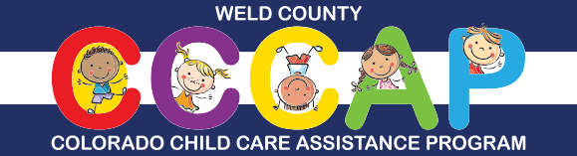
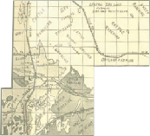For more information, call the Weld County CCCAP Team at (970) 400-6017 or email HS-CCCAP@weldgov.com
You may also check for eligibility and apply online through the Colorado PEAK® website at www.colorado.gov/PEAK

