Weld County Colorado Child Care Assistance Program (CCCAP) Income Eligibility Guidelines
Effective July 1, 2022

Family  Size | Gross Income Maximum at Program Entrance | Gross Income Maximum at Program Exit
2 | $2,903.33 | $5,111.45
3 | $3,660.00 | $6,314.14
4 | $4,416.67 | $7,516.83
5 | $5,173.33 | $8,719.53
6 | $5,930.00 | $9,922.22
7 | $6,686.67 | $10,147.73
8 | $7,443.33 | $10,373.23
9 | $8,200.00 | $10,598.74

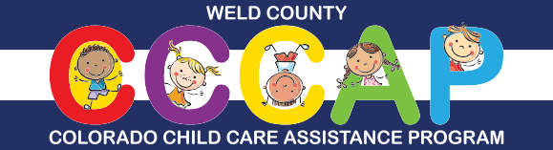
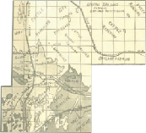For more information, call the Weld County CCCAP Team at (970) 400-6017 or email HS-CCCAP@weldgov.com
You may also check for eligibility and apply online through the Colorado PEAK® website at www.colorado.gov/PEAK

